**Project Report: Containerization of an Application**

**1. Introduction**

This project focuses on containerizing a multi-tier application stack that was previously running on virtual machines (VMs). The goal is to address several issues associated with the traditional deployment method and improve the overall efficiency and manageability of the application.

**2. Scenario**

* Multi-tier application stack
* Currently running on VMs
* Regular deployment cycles
* Continuous changes to the application

**3. Problems with Current Setup**

* High Capital Expenditure (CapEx) and Operational Expenditure (OpEx)
* Human errors during deployment
* Incompatibility with microservice architecture
* Resource wastage
* Lack of portability
* Environment synchronization issues

**4. Proposed Solution: Containerization**

**4.1 Benefits**

* Consumes low resources
* Well-suited for microservice design
* Deployment via container images
* Consistent container images across environments
* Reusable and repeatable deployment process

**4.2 Tools**

Docker will be used as the runtime environment for the Vprofile project.

**5. Implementation Steps**

1. Find the appropriate base image from Docker Hub
2. Write Dockerfile to customize images
3. Create a docker-compose.yml file to run multiple containers
4. Test the containerized application
5. Host the custom images on Docker Hub

**6. Workflow**

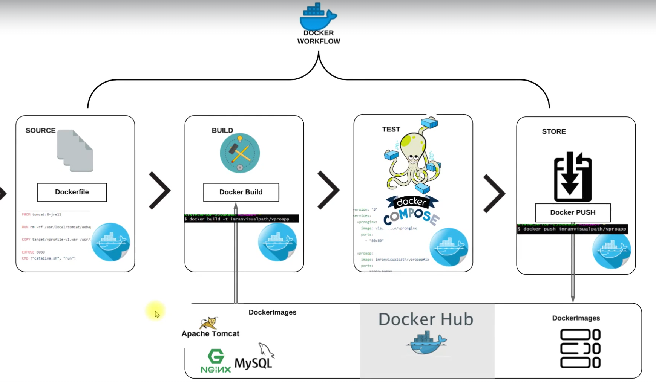

1. **Steps of execution**

Find the appropriate base image with tags from Docker Hub

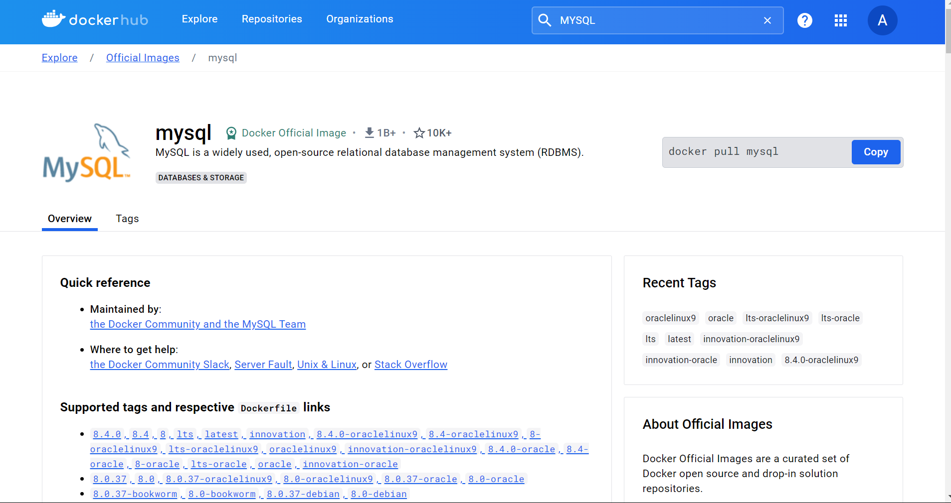

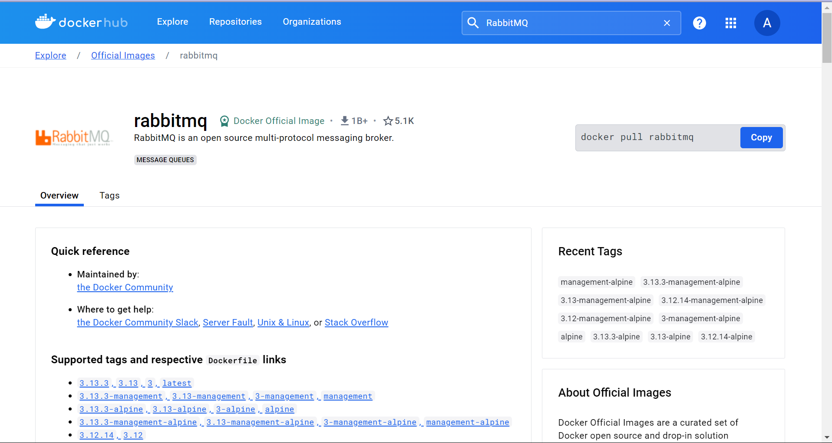

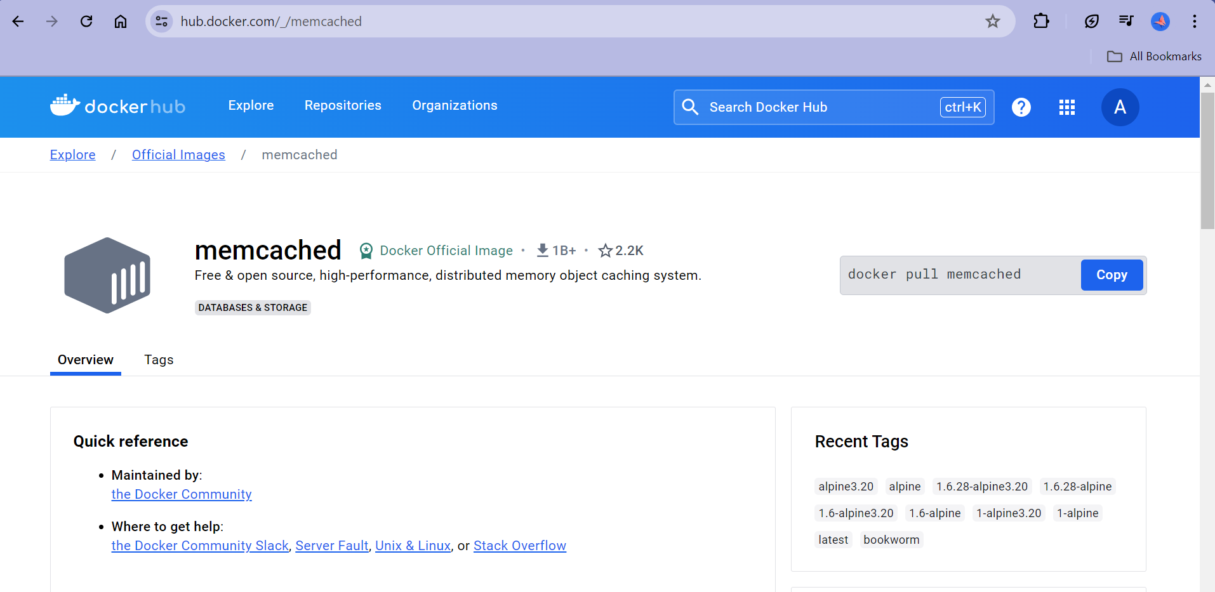

Docker hub setup

* + Use the Create Organizations from Organizations tab in docker hub to collaborate with your teammates in docker.

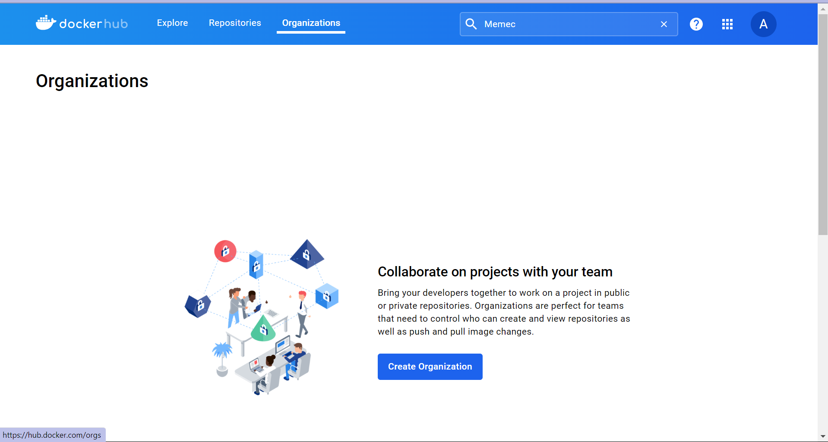

Setup docker-engine

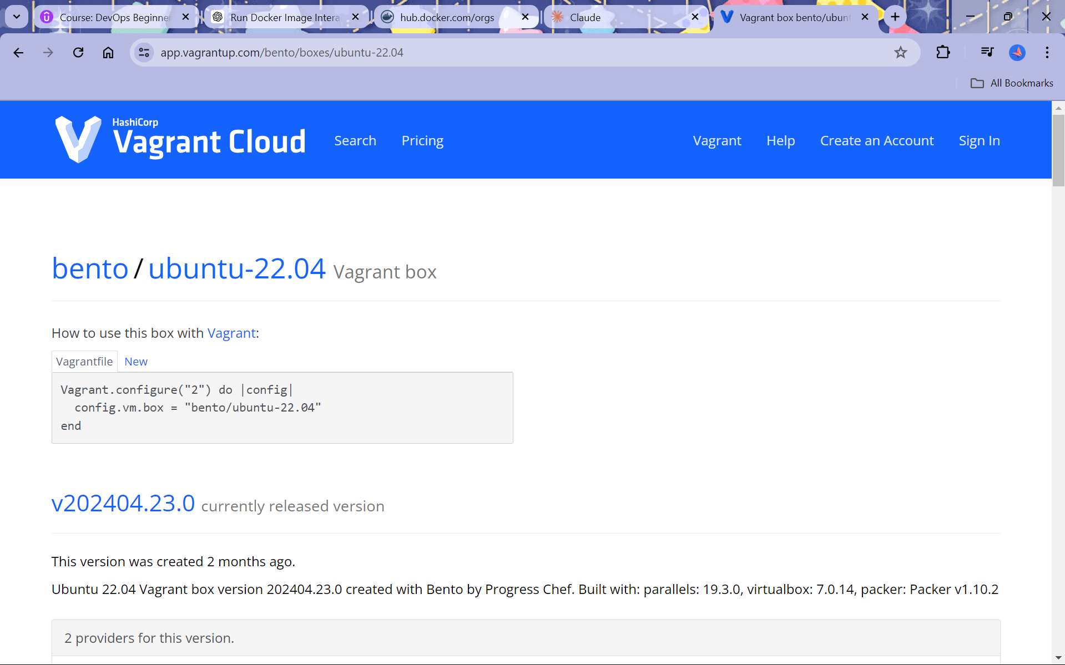

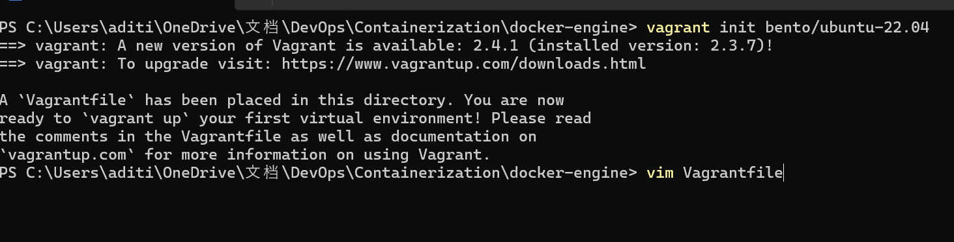

If Vim is not recognised I windows :

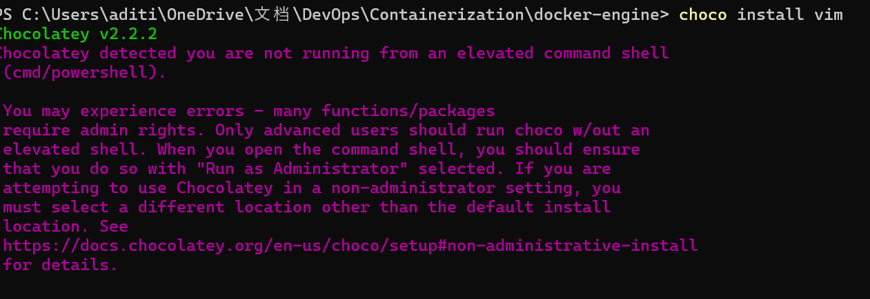

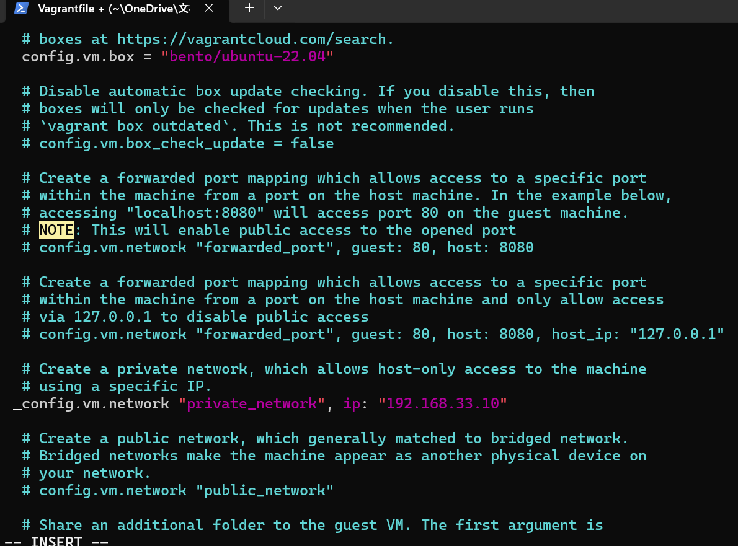

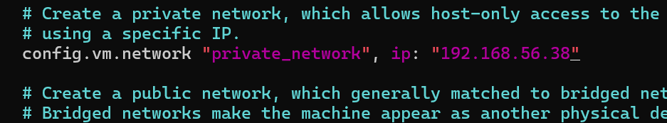

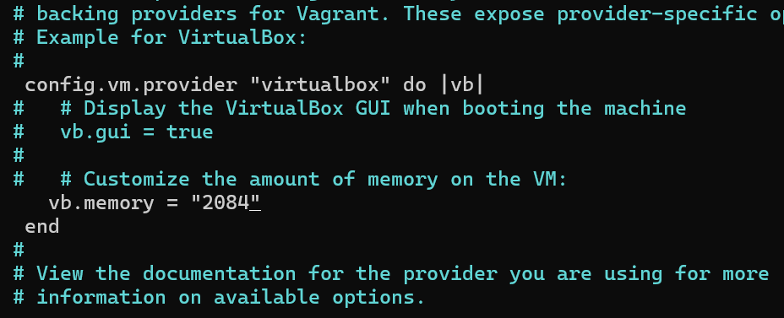

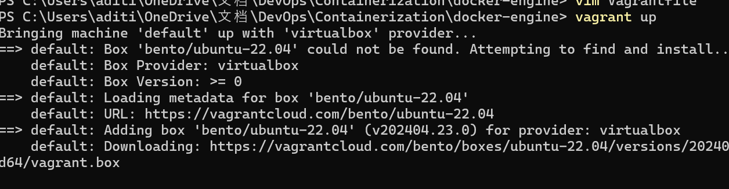

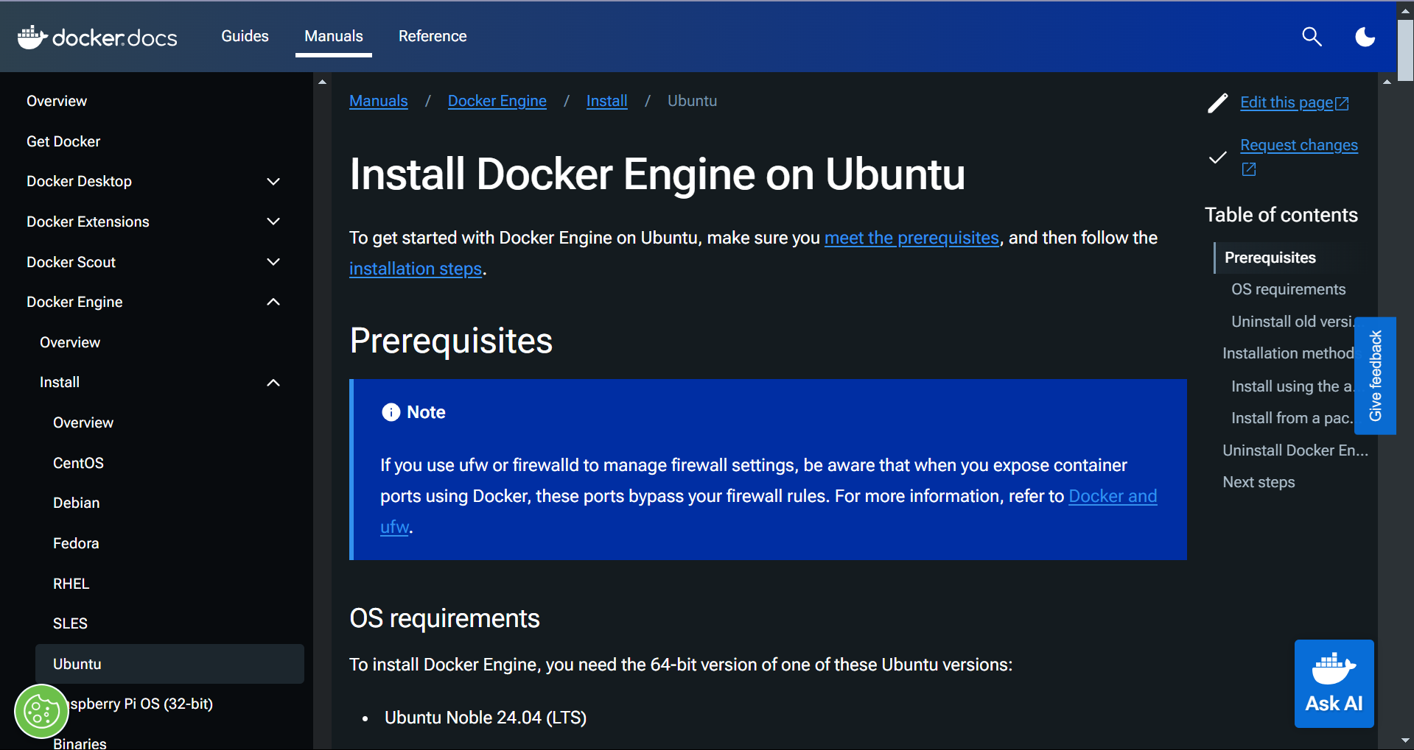

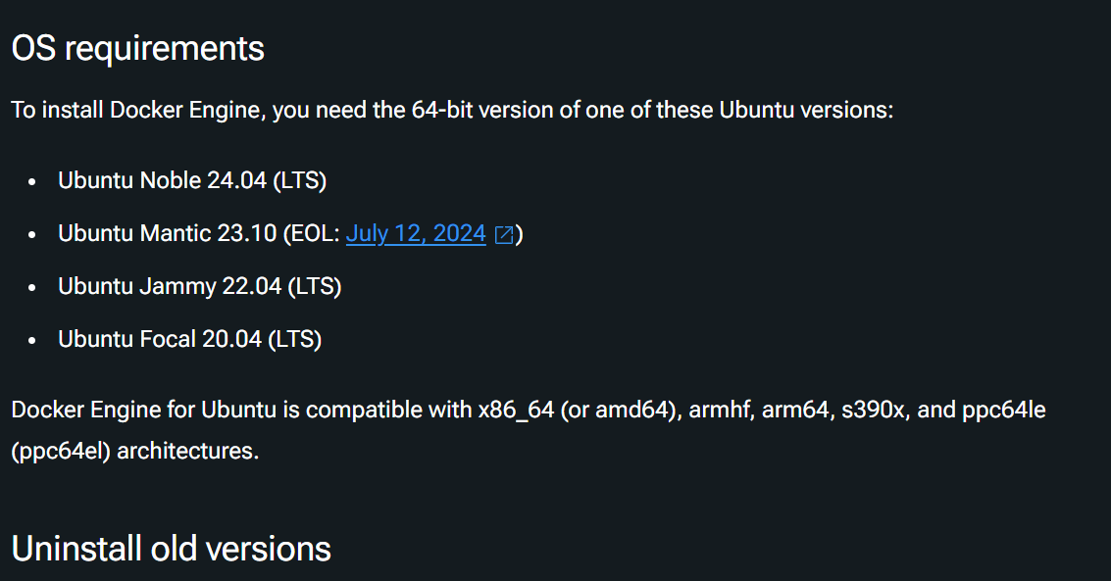

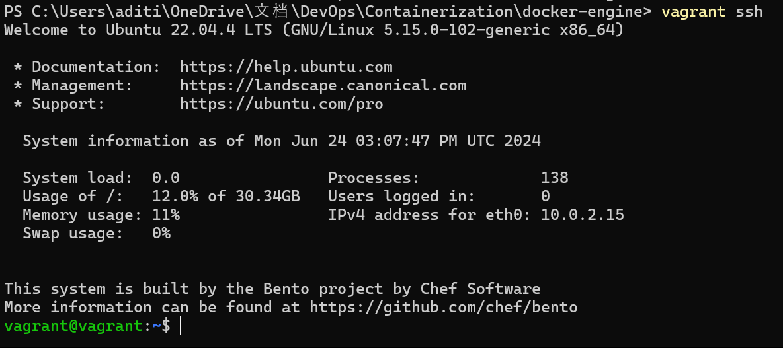

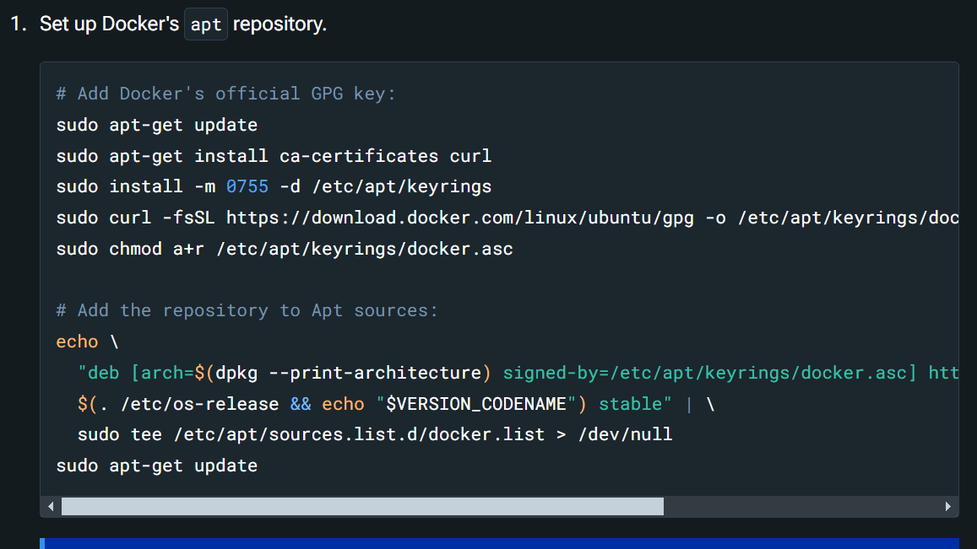Run all commands.

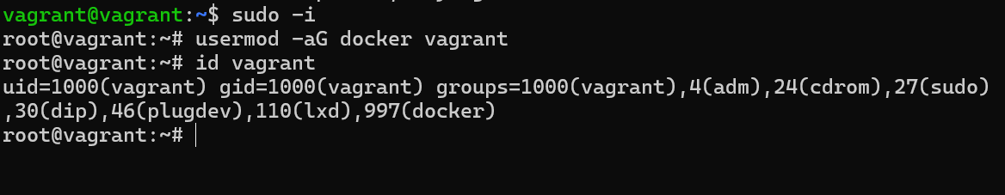

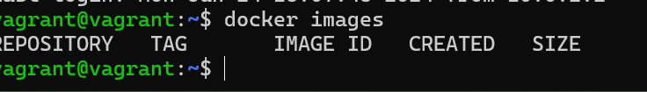

Log in to your GitHub account and access project where is it stored

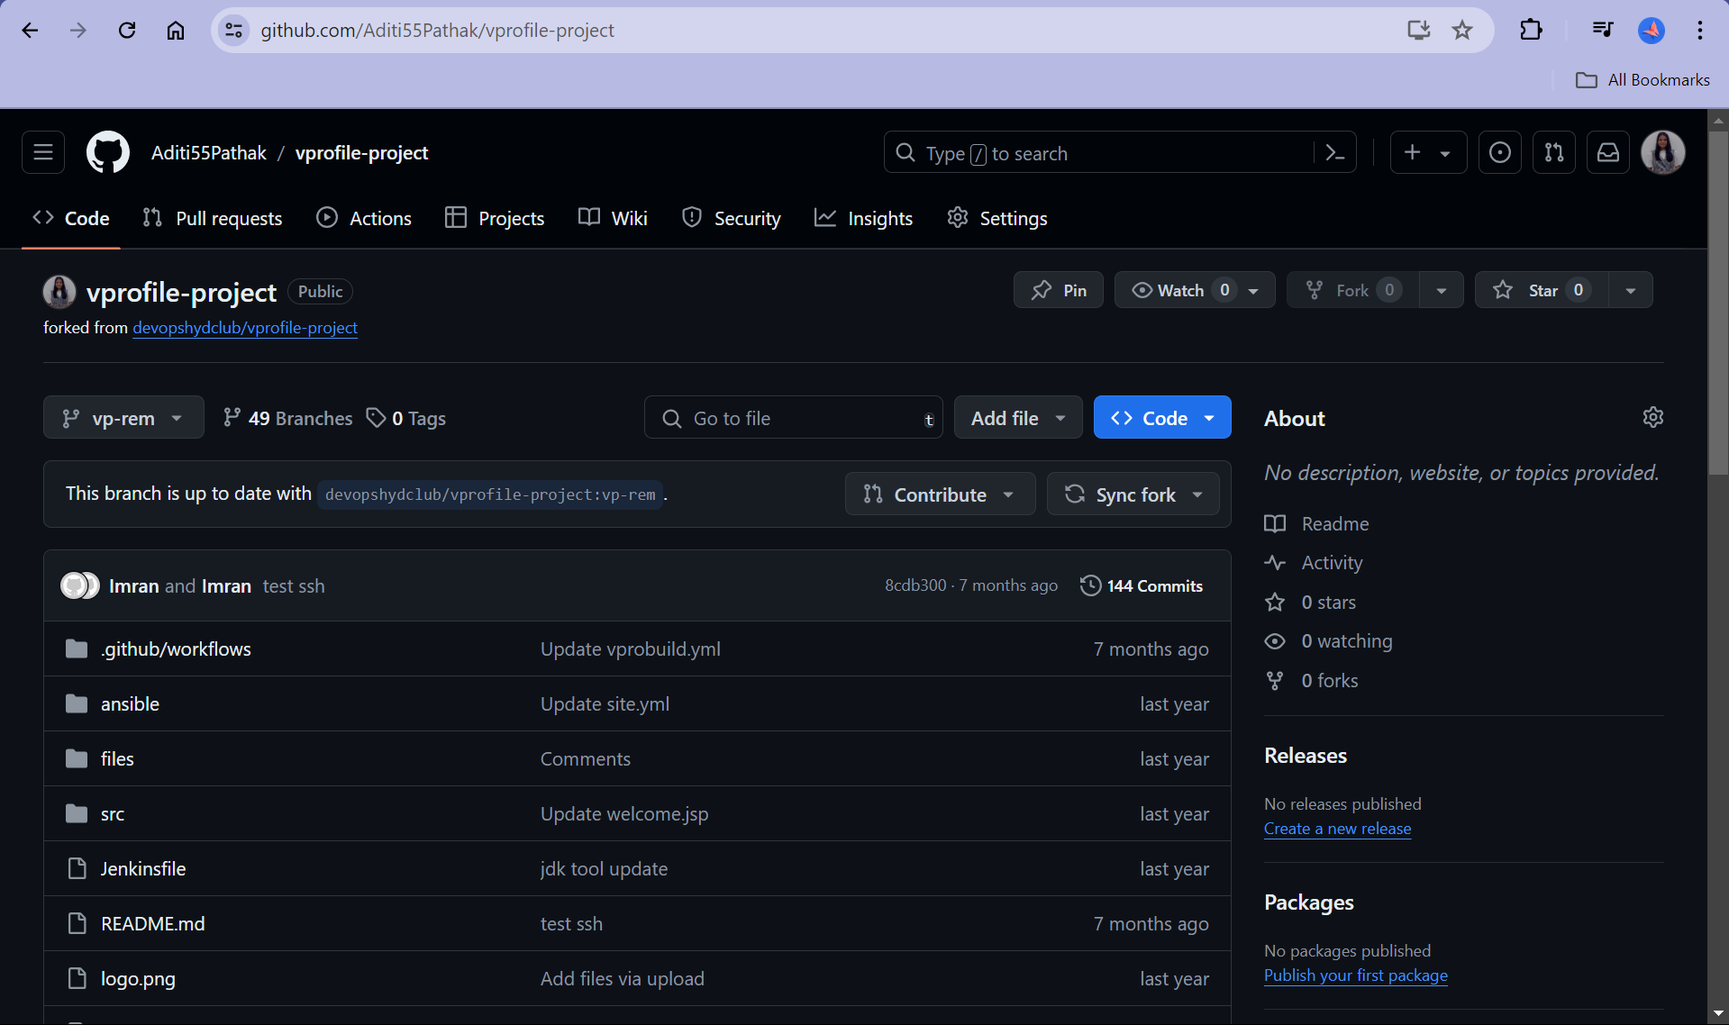

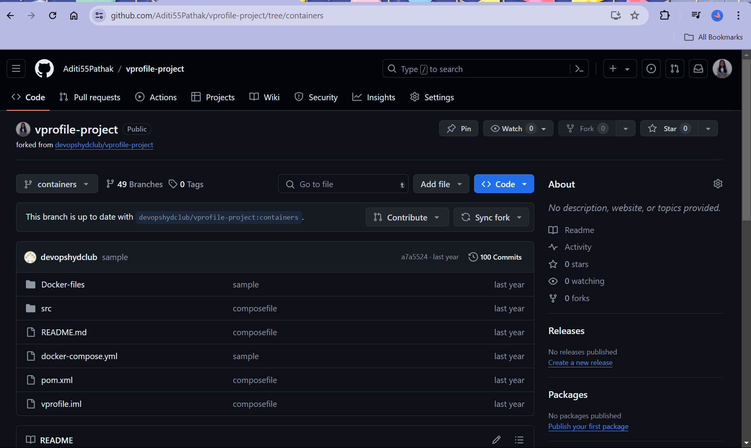

Clone this to local repository

Create a repository in Dockerhub

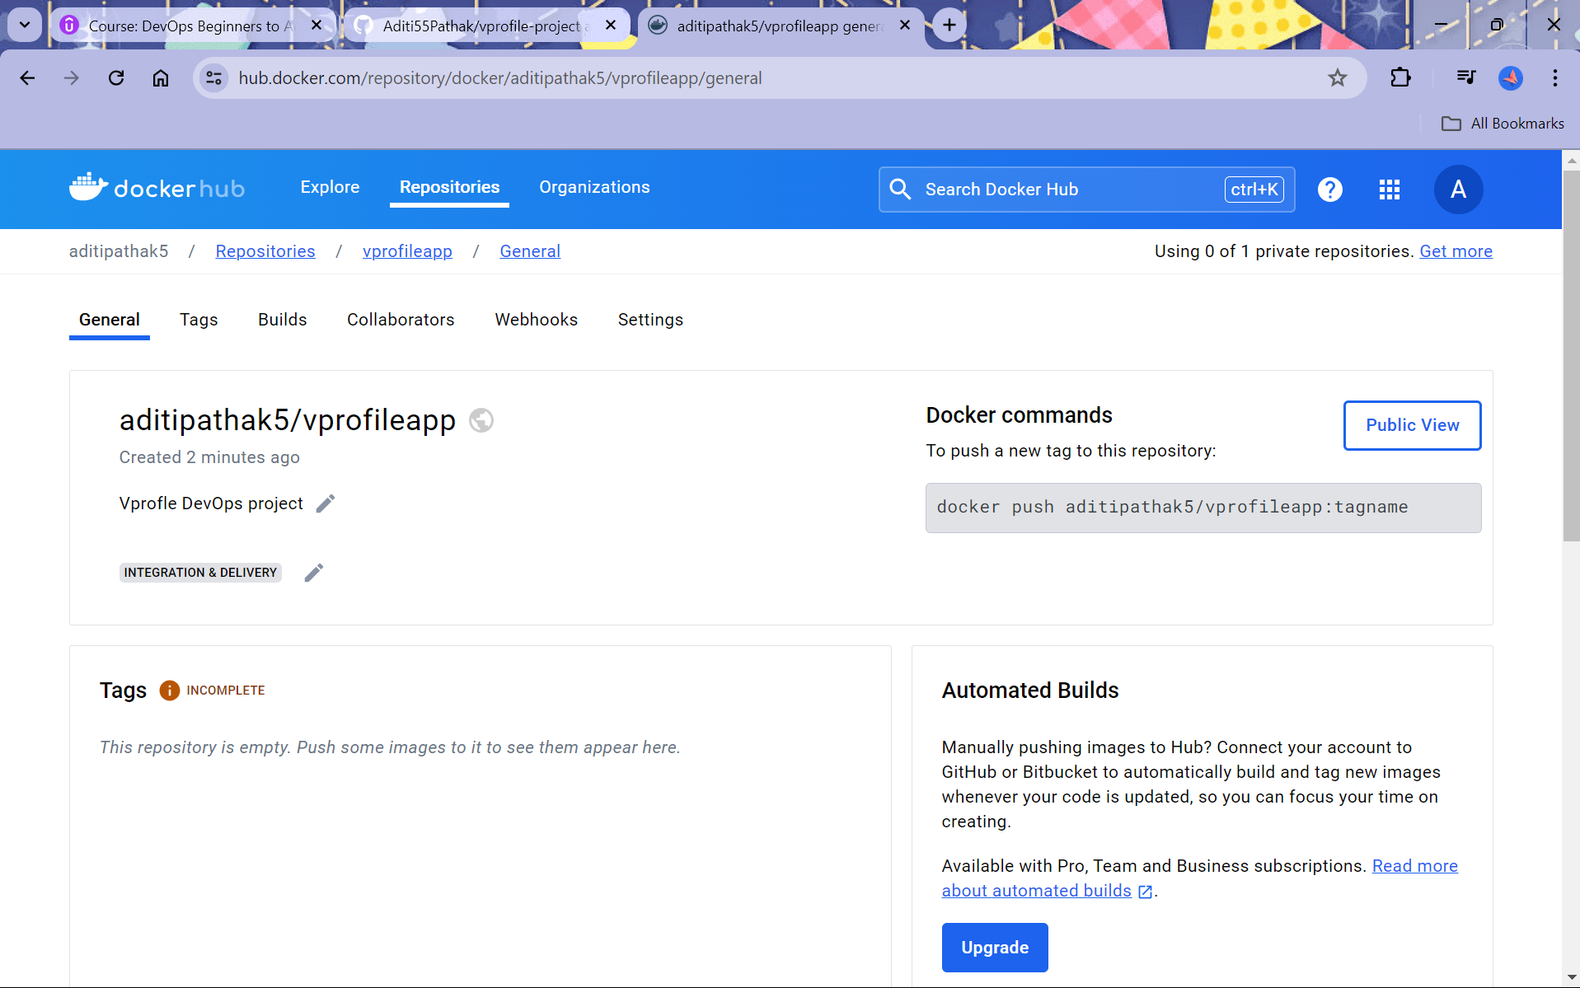

Let us build App image Dockerfile

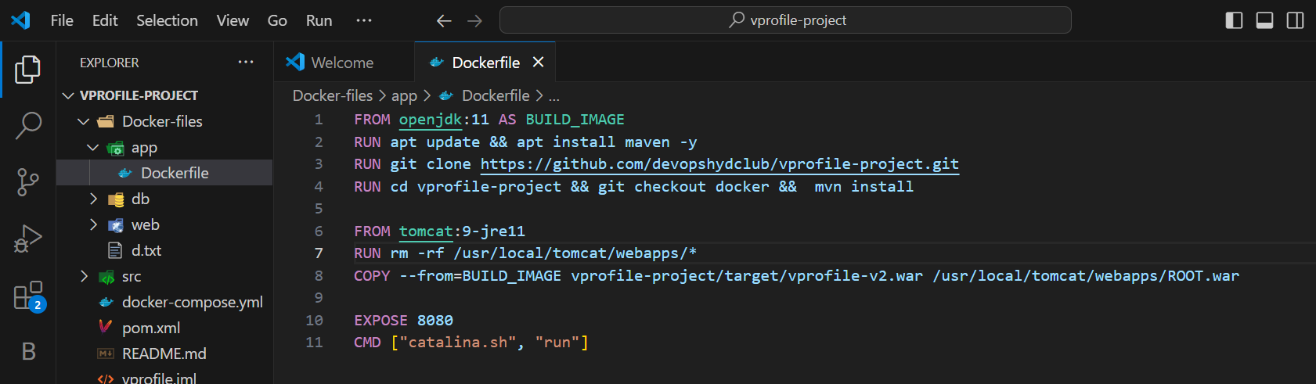

Let us build db image Dockerfile

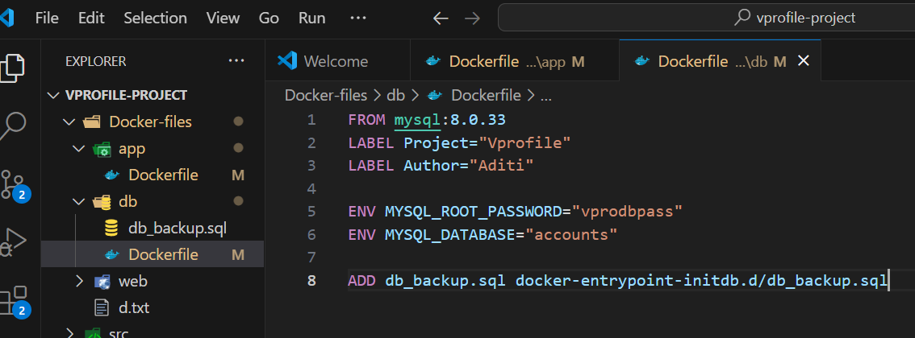

Let us build web image 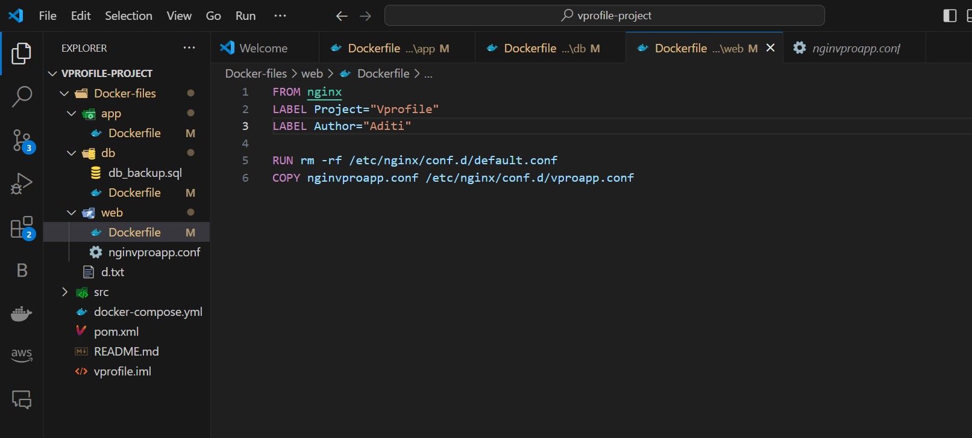

Make a docker compose file

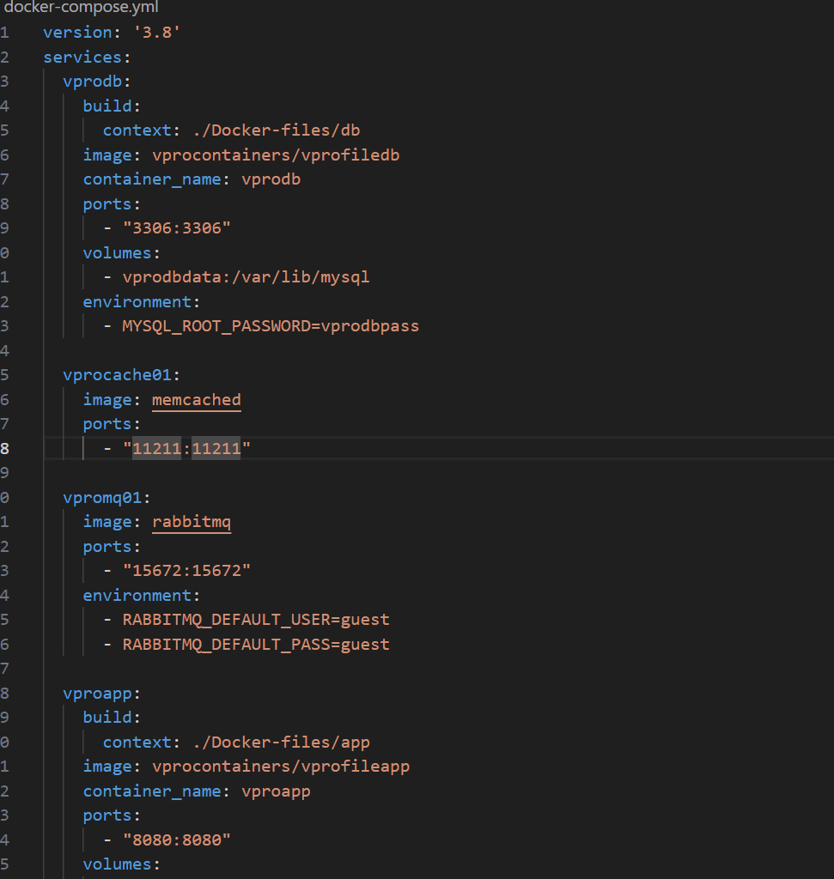

Build and Run

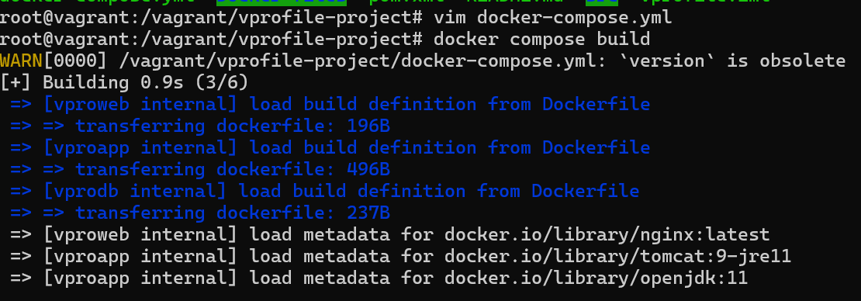

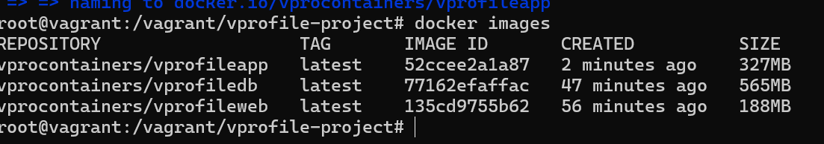

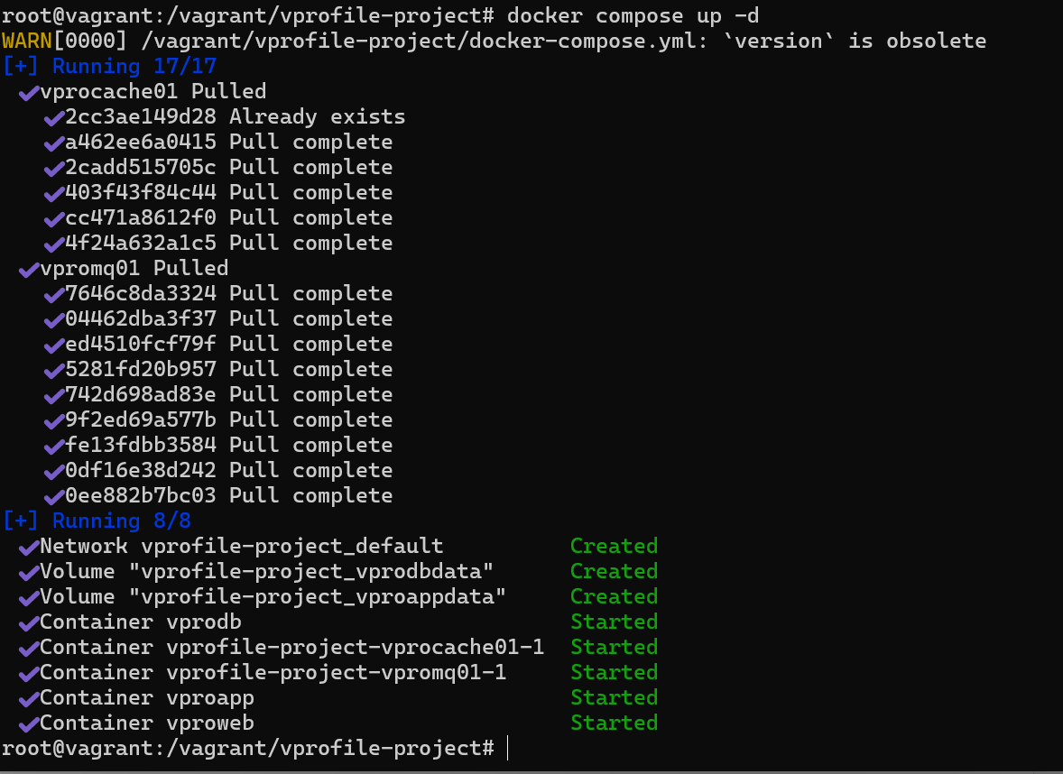

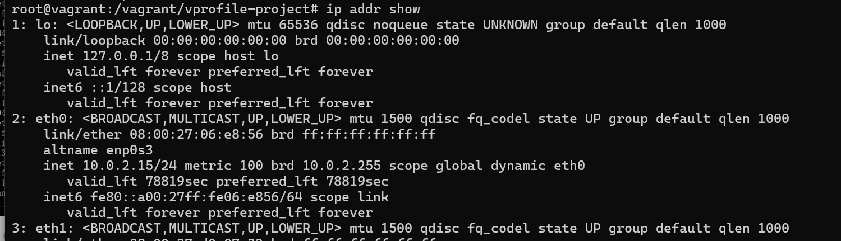

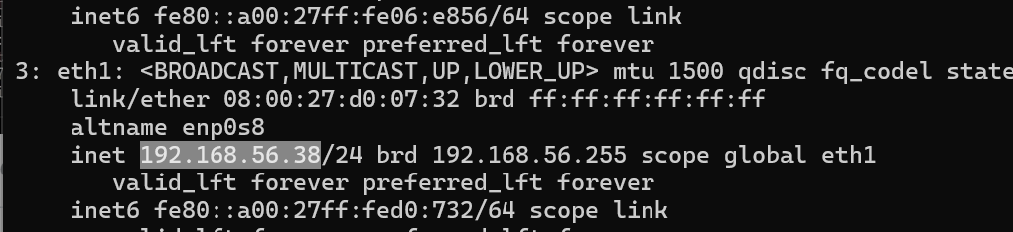

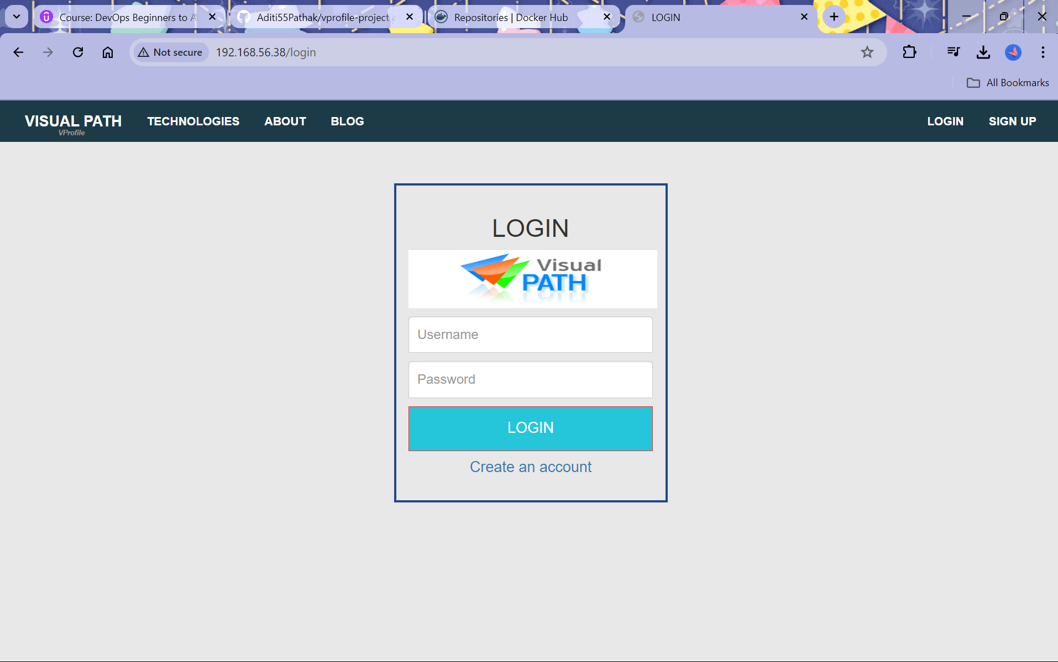

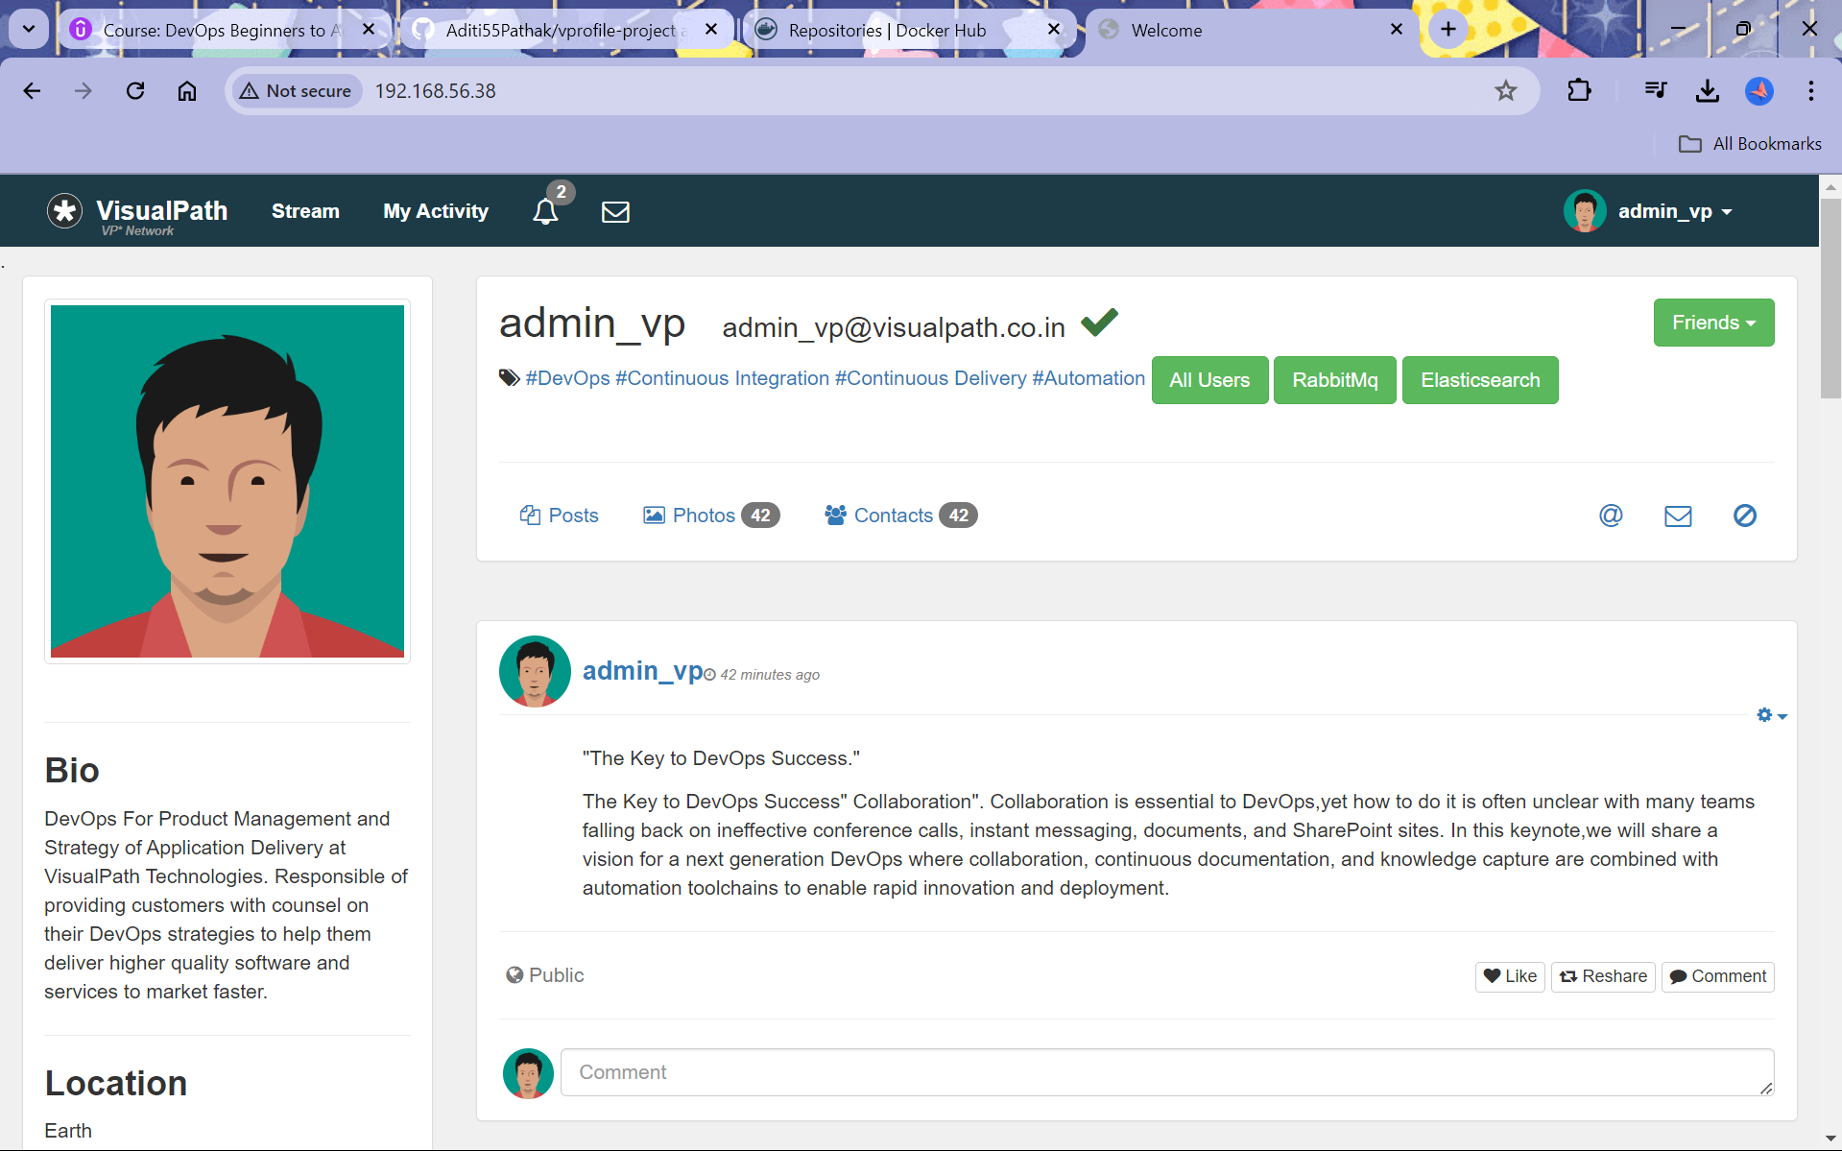

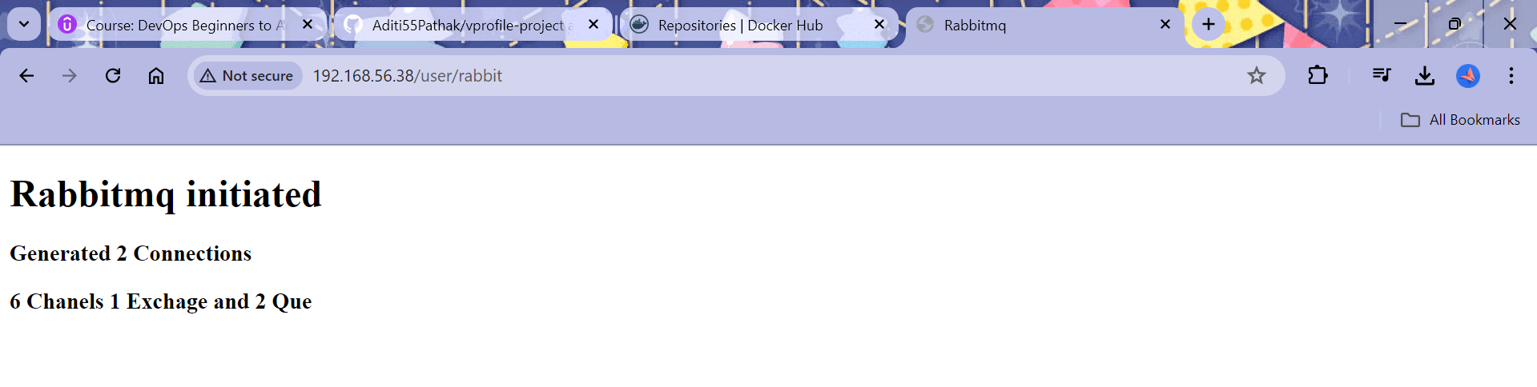

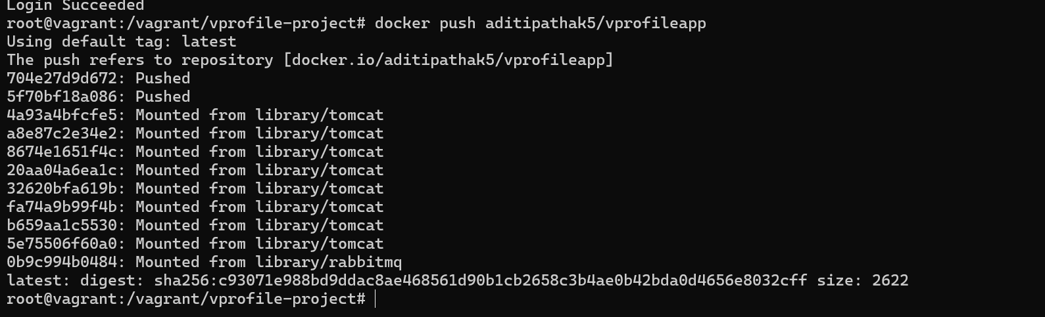

Cleanup

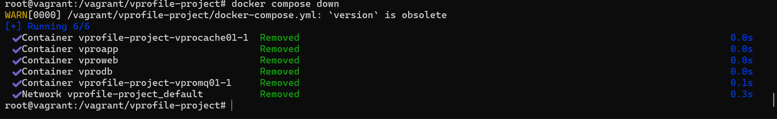

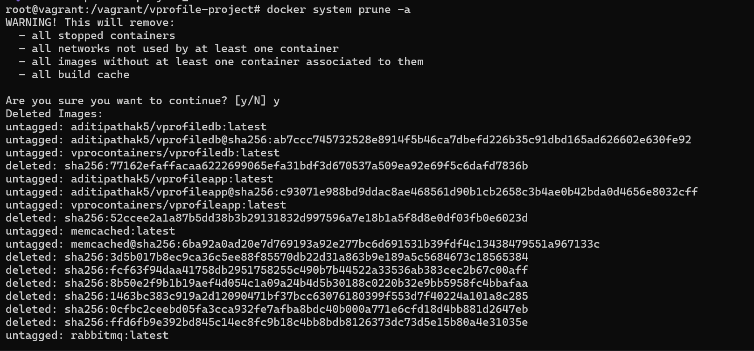

Final Commit

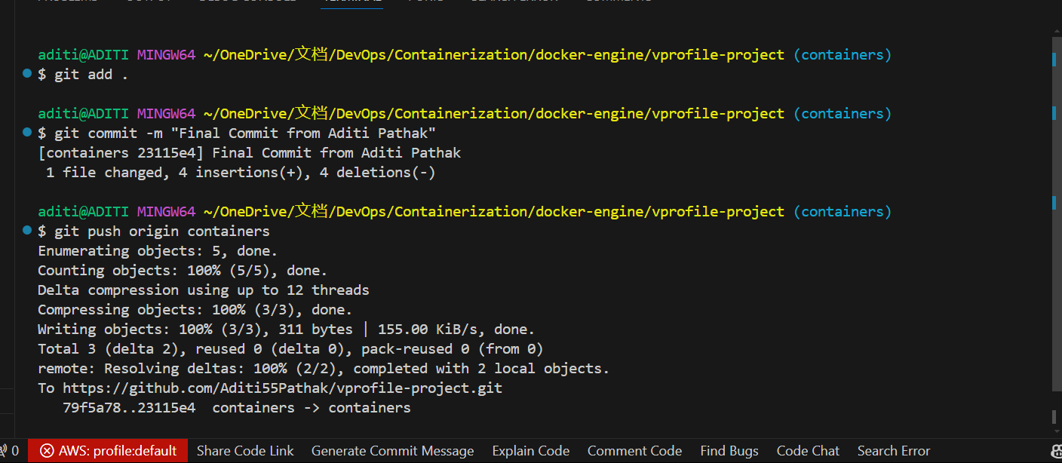

And You are all Done!!